[Maximum Product of Splitted Binary Tree](https://leetcode.com/problems/maximum-product-of-splitted-binary-tree/description/)

Given the root of a binary tree, split the binary tree into two subtrees by removing one edge such that the product of the sums of the subtrees is maximized.

Return *the maximum product of the sums of the two subtrees*. Since the answer may be too large, return it **modulo** 109 + 7.

**Note** that you need to maximize the answer before taking the mod and not after taking it.

**Example 1:**

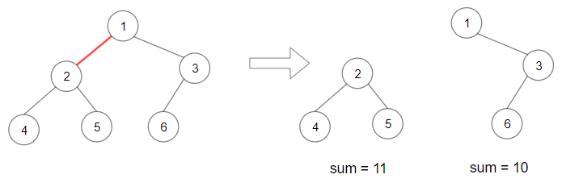

**Input:** root = [1,2,3,4,5,6]

**Output:** 110

**Explanation:** Remove the red edge and get 2 binary trees with sum 11 and 10. Their product is 110 (11*10)

**Example 2:**

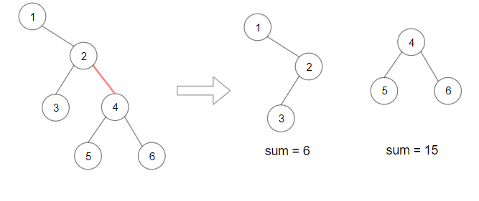

**Input:** root = [1,null,2,3,4,null,null,5,6]

**Output:** 90

**Explanation:** Remove the red edge and get 2 binary trees with sum 15 and 6.Their product is 90 (15*6)

**Constraints:**

* The number of nodes in the tree is in the range [2, 5 * 104].
* 1 <= Node.val <= 104